EXPERIMENT 20 — MYSQL STRING FUNCTIONS
I checked the manual carefully. The exact title is:
“MYSQL STRING FUNCTIONS- REPLACE, REPEAT, REVERSE, RIGHT, LEFT, RPAD, LPAD”
AIM
To implement Replace, Repeat, Reverse, Right, Left, Rpad and Lpad String Functions using MySQL.

Test REPLACE()
Replace Orange with Mango:
SELECT REPLACE('Orange Juice', 'Orange', 'Mango') AS result;
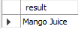

- REPLACE() replaces occurrences of one substring with another.

Test REPEAT()
SELECT REPEAT('Juice ', 3) AS result;
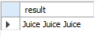

Test REVERSE()
SELECT REVERSE('Mango') AS result;
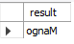

Test RIGHT()
SELECT RIGHT('Watermelon', 5) AS result;
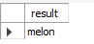

Test LEFT()
SELECT LEFT('Watermelon', 5) AS result;
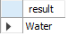
LEFT() extracts characters from the left side.

Test RPAD()
SELECT RPAD('Mango', 10, '*') AS result;
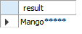

Test LPAD()
SELECT LPAD('Mango', 10, '*') AS result;
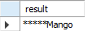

RESULT
Thus the MySQL string functions REPLACE, REPEAT, REVERSE, RIGHT, LEFT, RPAD and LPAD were successfully implemented.

